**SCHOOL OF COMPUTER SCIENCE**

**UNIVERSITY OF PETROLEUM AND ENERGY STUDIES**

**DEHRADUN, UTTARAKHAND**



**COMPUTER GRAPHICS**

**LABORATORY FILE**

**(2024-2025)**

**For**

**Vth Semester**

**Submitted To: Submitted By:**

Mr. Dinesh Akshat Negi

Assistant Professor 500106533(SAP ID)

[Vth Semester] R2142220414(Roll No.)

School of Computer Science B.Tech. CSF (Batch-1)

**LAB EXPERIMENT – 6**

**Basic 2D & 3D Transformations**

***# Perform all the experiment for 3-D transformation.***

***# Take the following values as input from user: Theta (angle of rotation), translation factor, scaling factor and other values. Make necessary assumptions.***

1. Write an interactive program for following basic transformation.
2. Translation
3. Rotation
4. Scaling
5. Reflection about axis.
6. Reflection about a line Y=mX+c and aX+bY+c=0.
7. Shear about an edge and about a vertex.

#include <GL/freeglut.h>

#include <iostream>

#include <cmath>

float angle = 0.0f; // Rotation angle

float tx = 0.0f, ty = 0.0f; // Translation factors

float sx = 1.0f, sy = 1.0f; // Scaling factors

float shearX = 0.0f, shearY = 0.0f; // Shear factors

float reflectionX = 1.0f, reflectionY = 1.0f; // Reflection factors

void drawSquare() {

glBegin(GL_LINE_LOOP);

glVertex2f(-0.5f, -0.5f);

glVertex2f(0.5f, -0.5f);

glVertex2f(0.5f, 0.5f);

glVertex2f(-0.5f, 0.5f);

glEnd();

}

// Apply translation transformation

void translate(float x, float y) {

glTranslatef(x, y, 0.0f);

}

// Apply rotation transformation

void rotate(float angle) {

glRotatef(angle, 0.0f, 0.0f, 1.0f);

}

// Apply scaling transformation

void scale(float x, float y) {

glScalef(x, y, 1.0f);

}

// Apply reflection

void reflect(bool x, bool y) {

reflectionX = x ? -1.0f : 1.0f;

reflectionY = y ? -1.0f : 1.0f;

glScalef(reflectionX, reflectionY, 1.0f);

}

// Apply shear transformation

void shear(float shx, float shy) {

GLfloat shearMatrix[16] = {

1.0f, shx, 0.0f, 0.0f,

shy, 1.0f, 0.0f, 0.0f,

0.0f, 0.0f, 1.0f, 0.0f,

0.0f, 0.0f, 0.0f, 1.0f

};

glMultMatrixf(shearMatrix);

}

void display() {

glClear(GL_COLOR_BUFFER_BIT);

glLoadIdentity();

// Apply transformations in the order: translate, rotate, scale, reflect, shear

translate(tx, ty);

rotate(angle);

scale(sx, sy);

reflect(reflectionX < 0, reflectionY < 0);

shear(shearX, shearY);

drawSquare();

glutSwapBuffers();

}

// Handle keyboard input for transformations

void keyboard(unsigned char key, int x, int y) {

switch (key) {

case 'r': // Rotate

std::cout << "Enter rotation angle: ";

std::cin >> angle;

break;

case 't': // Translate

std::cout << "Enter translation factors (tx ty): ";

std::cin >> tx >> ty;

break;

case 's': // Scale

std::cout << "Enter scaling factors (sx sy): ";

std::cin >> sx >> sy;

break;

case 'x': // Reflect about X-axis

reflectionX = -reflectionX;

break;

case 'y': // Reflect about Y-axis

reflectionY = -reflectionY;

break;

case 'h': // Shear

std::cout << "Enter shear factors (shearX shearY): ";

std::cin >> shearX >> shearY;

break;

case 27: // Escape key to exit

exit(0);

}

glutPostRedisplay();

}

void init() {

glClearColor(0.0f, 0.0f, 0.0f, 1.0f);

glMatrixMode(GL_PROJECTION);

gluOrtho2D(-2.0, 2.0, -2.0, 2.0); // Set up a 2D orthogonal projection

glMatrixMode(GL_MODELVIEW);

}

int main(int argc, char** argv) {

glutInit(&argc, argv);

glutInitDisplayMode(GLUT_DOUBLE | GLUT_RGB);

glutInitWindowSize(600, 600);

glutCreateWindow("2D Transformations - Akshat Negi");

init();

glutDisplayFunc(display);

glutKeyboardFunc(keyboard);

glutMainLoop();

return 0;

}

**Interaction:**

**Keyboard keys:**

**r: Prompts for rotation angle.**

**t: Prompts for translation factors (tx, ty).**

**s: Prompts for scaling factors (sx, sy).**

**x, y: Reflects about the X or Y axis, respectively.**

**h: Prompts for shear factors (shearX, shearY).**

**Esc: Exits the program.**

**SAMPLE INPUT**

**Enter rotation angle:**

**30**

**Enter translation factors (tx ty):**

**1.0 0.5**

**Enter scaling factors (sx sy):**

**2.0 0.5**

**Press 'x' for reflection about X-axis**

**Press 'h' for shear factors:**

**Enter shear factors (shearX shearY):**

**0.2 0.0**

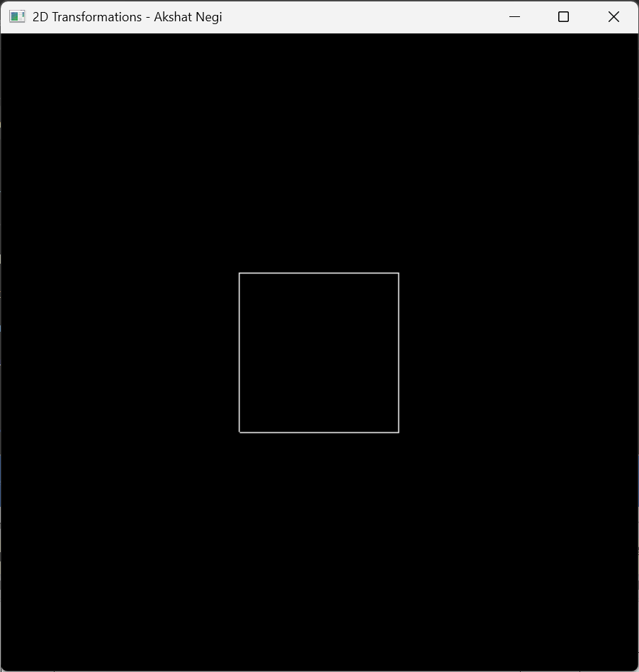

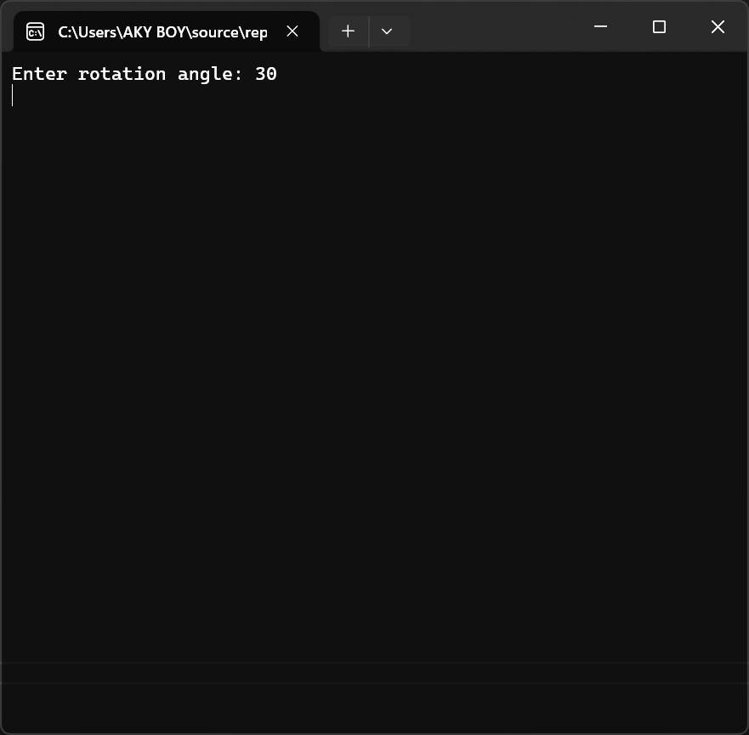

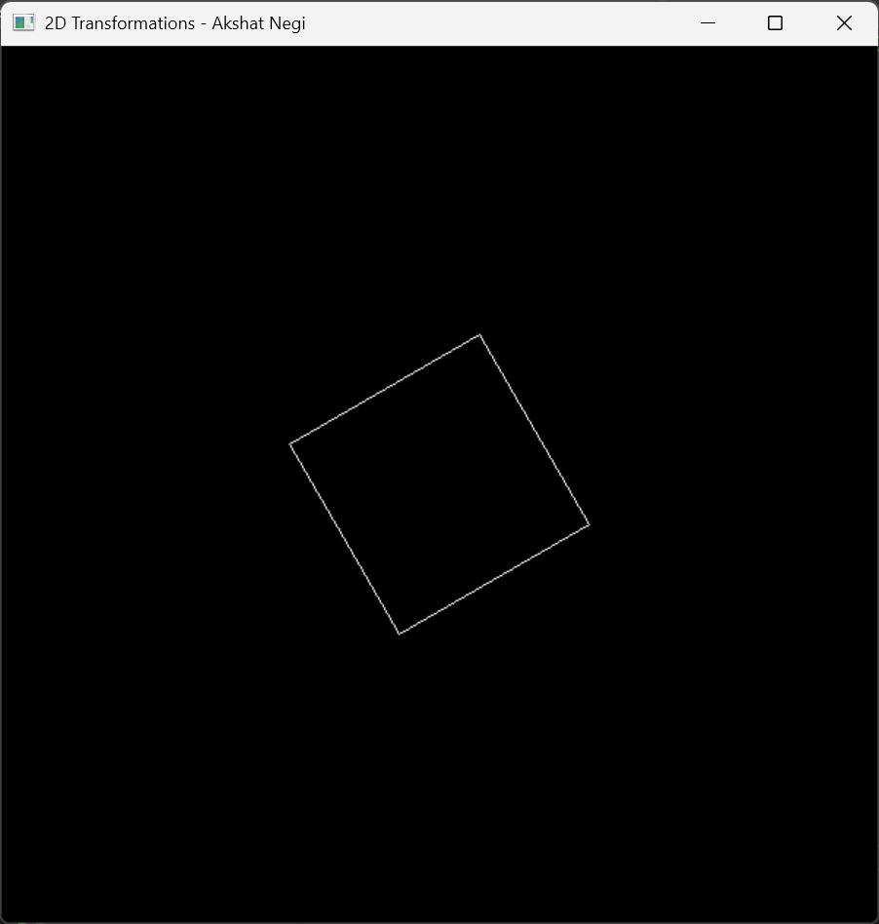

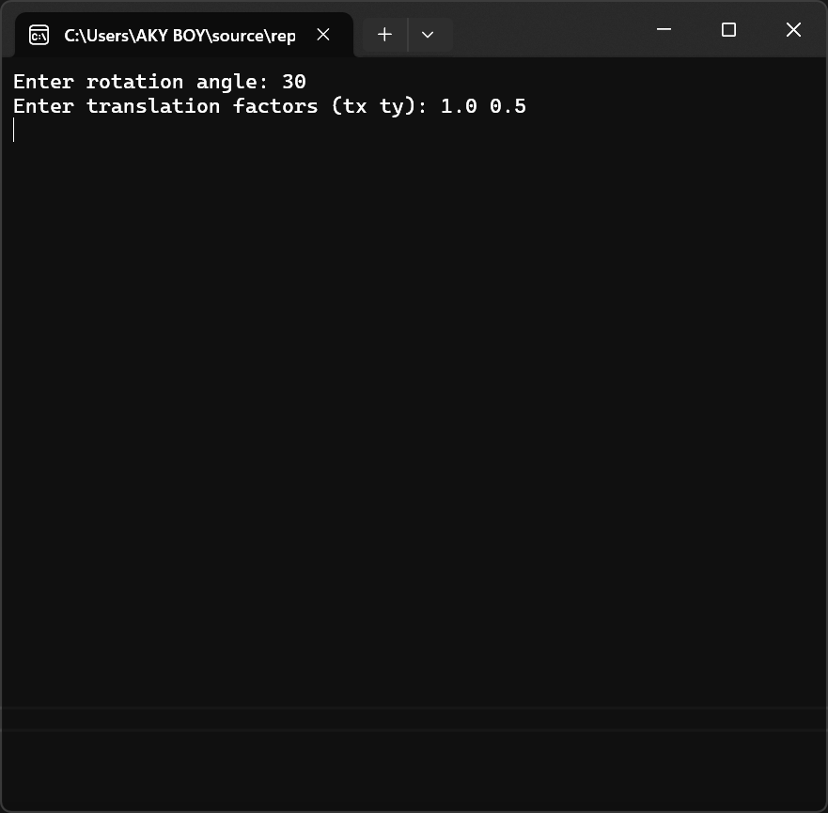

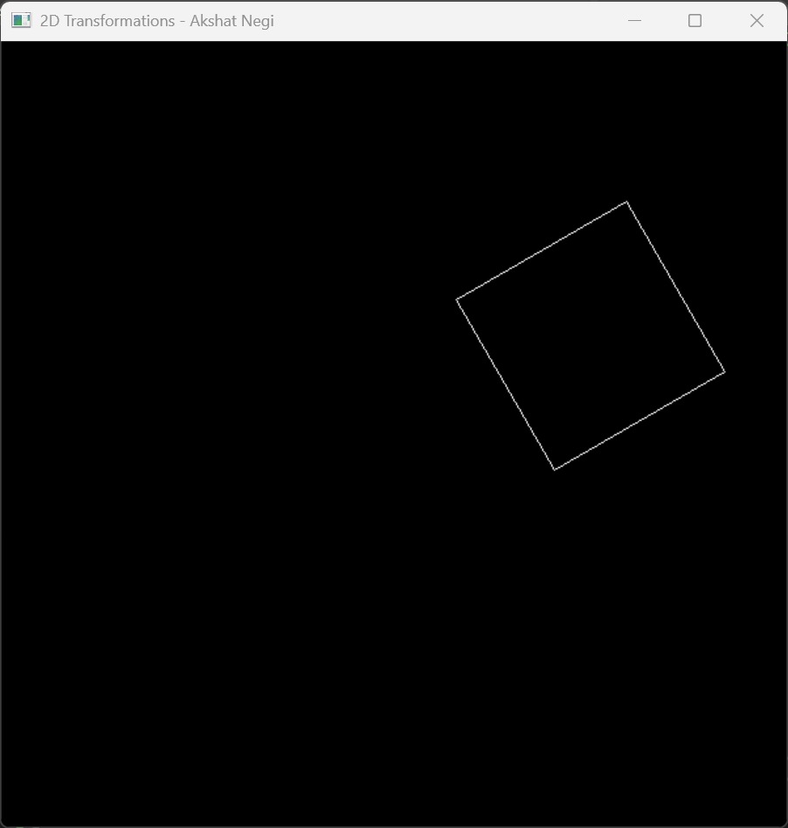

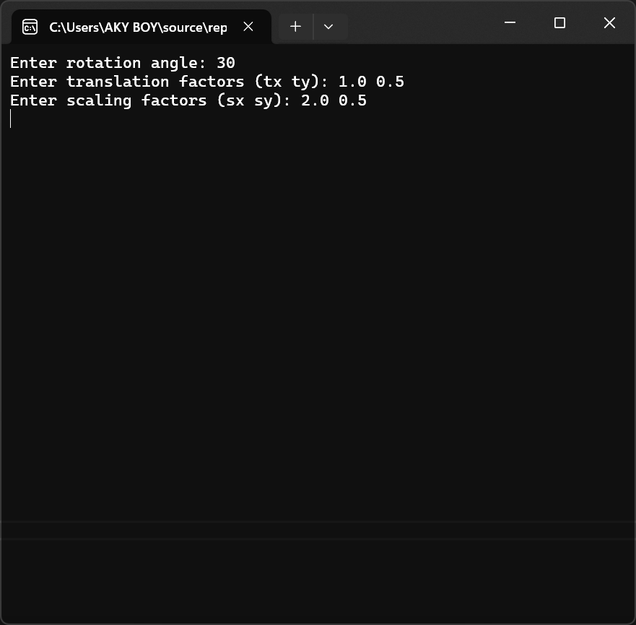

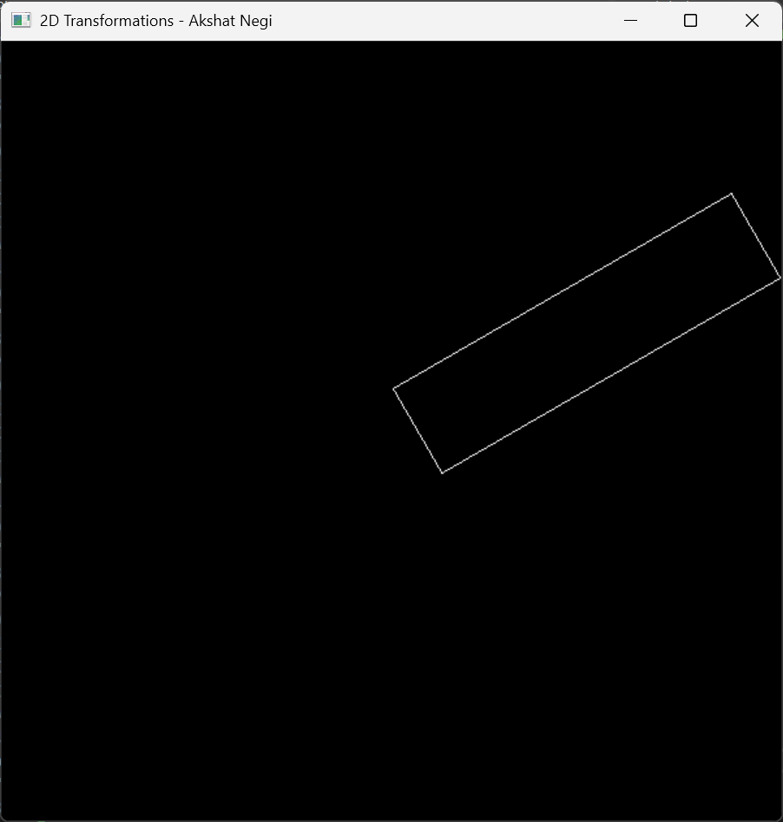

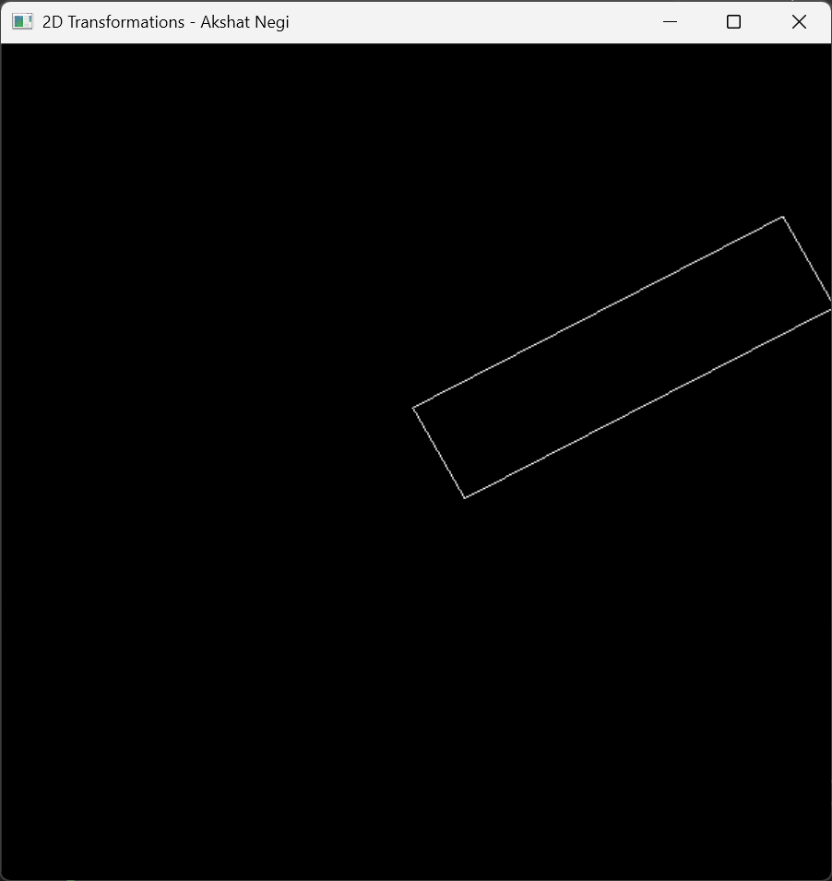

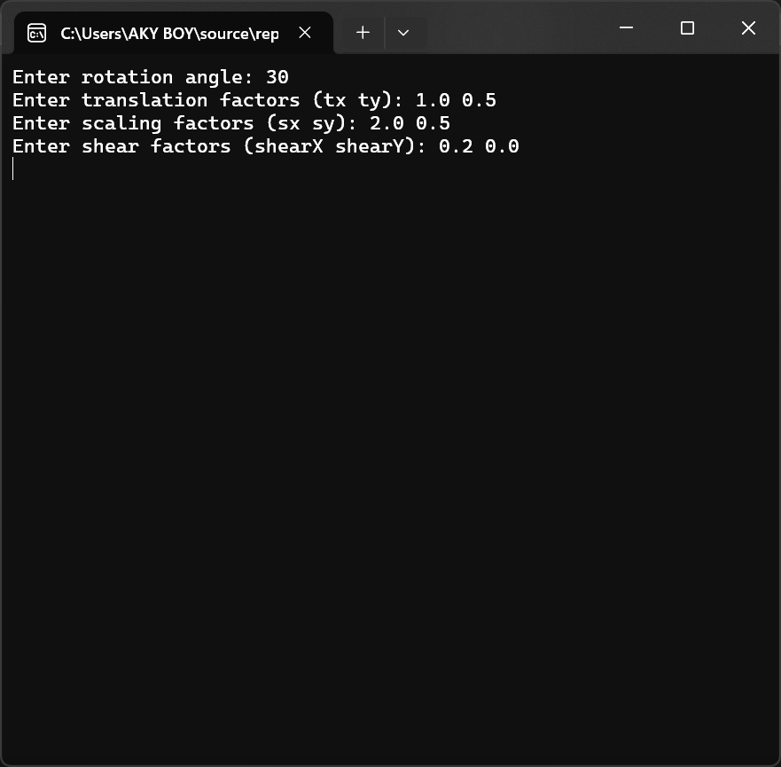

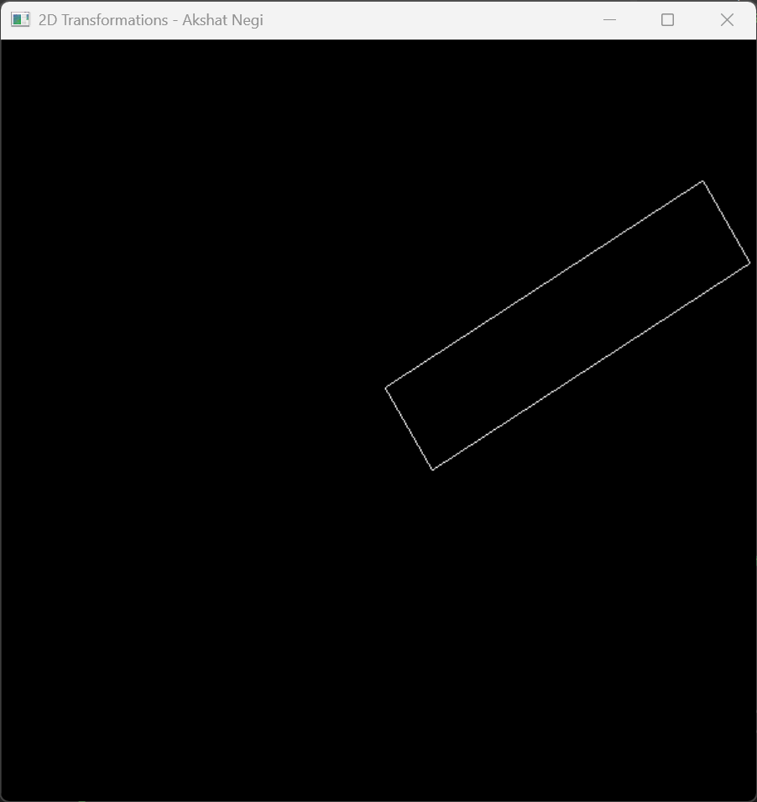

**#include <GL/freeglut.h>**

**#include <iostream>**

**#include <cmath>**

**float theta = 0.0f; // Rotation angle**

**float tx = 0.0f, ty = 0.0f, tz = 0.0f; // Translation factors**

**float sx = 1.0f, sy = 1.0f, sz = 1.0f; // Scaling factors**

**float shearX = 0.0f, shearY = 0.0f, shearZ = 0.0f; // Shear factors**

**float reflectionX = 1.0f, reflectionY = 1.0f, reflectionZ = 1.0f; // Reflection factors**

**void drawCube() {**

**glutWireCube(1.0); // Draw a unit cube**

**}**

**// Apply translation transformation**

**void translate(float x, float y, float z) {**

**glTranslatef(x, y, z);**

**}**

**// Apply rotation transformation**

**void rotate(float angle, float x, float y, float z) {**

**glRotatef(angle, x, y, z);**

**}**

**// Apply scaling transformation**

**void scale(float x, float y, float z) {**

**glScalef(x, y, z);**

**}**

**// Apply reflection about axis**

**void reflect(bool x, bool y, bool z) {**

**reflectionX = x ? -1.0f : 1.0f;**

**reflectionY = y ? -1.0f : 1.0f;**

**reflectionZ = z ? -1.0f : 1.0f;**

**glScalef(reflectionX, reflectionY, reflectionZ);**

**}**

**// Apply shear transformation**

**void shear(float shx, float shy, float shz) {**

**GLfloat shearMatrix[16] = {**

**1.0f, shx, 0.0f, 0.0f,**

**shy, 1.0f, 0.0f, 0.0f,**

**0.0f, shz, 1.0f, 0.0f,**

**0.0f, 0.0f, 0.0f, 1.0f**

**};**

**glMultMatrixf(shearMatrix);**

**}**

**void display() {**

**glClear(GL_COLOR_BUFFER_BIT | GL_DEPTH_BUFFER_BIT);**

**glLoadIdentity();**

**glTranslatef(0.0f, 0.0f, -5.0f); // Position the object**

**// Apply transformations in the order: translate, rotate, scale, reflect, shear**

**translate(tx, ty, tz);**

**rotate(theta, 1.0f, 1.0f, 1.0f);**

**scale(sx, sy, sz);**

**reflect(reflectionX < 0, reflectionY < 0, reflectionZ < 0);**

**shear(shearX, shearY, shearZ);**

**drawCube();**

**glutSwapBuffers();**

**}**

**// Handle keyboard input for transformations**

**void keyboard(unsigned char key, int x, int y) {**

**switch (key) {**

**case 'r': // Rotate**

**std::cout << "Enter rotation angle: ";**

**std::cin >> theta;**

**break;**

**case 't': // Translate**

**std::cout << "Enter translation factors (tx ty tz): ";**

**std::cin >> tx >> ty >> tz;**

**break;**

**case 's': // Scale**

**std::cout << "Enter scaling factors (sx sy sz): ";**

**std::cin >> sx >> sy >> sz;**

**break;**

**case 'x': // Reflect about X-axis**

**reflectionX = -reflectionX;**

**break;**

**case 'y': // Reflect about Y-axis**

**reflectionY = -reflectionY;**

**break;**

**case 'z': // Reflect about Z-axis**

**reflectionZ = -reflectionZ;**

**break;**

**case 'h': // Shear**

**std::cout << "Enter shear factors (shearX shearY shearZ): ";**

**std::cin >> shearX >> shearY >> shearZ;**

**break;**

**case 27: // Escape key to exit**

**exit(0);**

**}**

**glutPostRedisplay();**

**}**

**void init() {**

**glEnable(GL_DEPTH_TEST);**

**glClearColor(0.0f, 0.0f, 0.0f, 1.0f);**

**glMatrixMode(GL_PROJECTION);**

**gluPerspective(45.0, 1.0, 1.0, 100.0);**

**glMatrixMode(GL_MODELVIEW);**

**}**

**int main(int argc, char** argv) {**

**glutInit(&argc, argv);**

**glutInitDisplayMode(GLUT_DOUBLE | GLUT_RGB | GLUT_DEPTH);**

**glutInitWindowSize(600, 600);**

**glutCreateWindow("3D Transformations - Akshat Negi");**

**init();**

**glutDisplayFunc(display);**

**glutKeyboardFunc(keyboard);**

**glutMainLoop();**

**return 0;**

**}**

**Interaction:**

**Keyboard keys:**

**r: Prompts for rotation angle.**

**t: Prompts for translation factors (tx, ty, tz).**

**s: Prompts for scaling factors (sx, sy, sz).**

**x, y, z: Reflects about X, Y, or Z axes.**

**h: Prompts for shear factors (shearX, shearY, shearZ).**

**Esc: Exits the program.**

**SAMPLE INPUT**

**Enter rotation angle:**

**45**

**Enter translation factors (tx ty tz):**

**2.0 1.0 -1.5**

**Enter scaling factors (sx sy sz):**

**1.5 0.5 2.0**

**Press 'x' for reflection about X-axis**

**Press 'h' for shear factors:**

**Enter shear factors (shearX shearY shearZ):**

**0.5 0.0 1.0**

